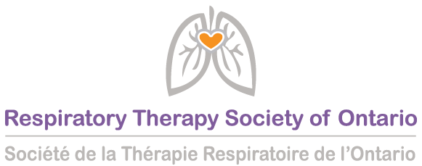
Dear Member of Provincial Parliament
The Respiratory Therapy Society of Ontario (RTSO) is seeking your support for our application to amend the Controlled Acts Regulation (o. Reg. 107/96) of the Regulated Health Professions Act (RHPA) in relation to the use of “soundwaves for diagnostic ultrasound” for specific procedures within a Respiratory Therapist’s scope of practice in the acute care setting.
Respiratory Therapists (RTs) manage the cardiorespiratory care of patients. In acute care, when a patient has difficulty breathing or has chest pains, we are often first on the scene to assess and treat the patient using various medical procedures, therapies, and medications. Respiratory Therapists are vital members of the health team alongside physicians and nurses. We are relied upon to test and monitor breathing, heart rate, blood pressure, oxygen, and blood gas levels, as well as to insert arterial lines, intubate and connect patients to ventilators. After which we oversee keeping that patient stable.
In 2017, this regulation was opened and amended through the former government’s Bill 160: Strengthening Quality and Accountability for Patients Act. To the best of our knowledge, an oversight was made by regulators at the time, likely due to a lack of understanding of our professional practice. This caused a regulatory ripple effect whereby the o. Reg. 107/96 substituted “a person” with “A member of the College of Medical Radiation and Imaging Technologists of Ontario or a member of the College of Nurses of Ontario.” This essentially limited the use of ultrasound for Respiratory Therapists. We are seeking an addition to this Regulation, specifically Exemptions, s.7.1(1) to include “A member of the College of Respiratory Therapists of Ontario”.
Our profession has the competency and experience to use ultrasound for multiple procedures, particularly to insert catheters into both arteries and veins to administer lifesaving treatments and medications. Physicians and nurses need us to perform these procedures quickly and safely. However, since the change was officially made in January 2019, RTs have reverted to traditional palpation techniques which is far less accurate, often involving multiple attempts and more equipment. In many cases, the health team must wait for the physician to either delegate or perform the procedure themselves. This is a complete waste of time and resources causing unnecessary and risky delays resulting in issues that negatively impact patient care and outcomes.
Currently, Respiratory Therapists are experiencing inconsistent practices in hospitals across the province which translates into sub-optimal practices for patient care. Some hospitals have the capacity to create the medical directive and training program where others do not have the same capacity or resources, thereby providing inconsistent care for Ontarians.
Our professional association would really appreciate the opportunity to speak to you further about this as it impacts people in your riding.
During a global health pandemic, we do not have the time to deal with unnecessary red tape and duplication of precious resources (i.e. frontline healthcare workers, medical equipment, and PPE) when our hospitals need to be operating at peak performance.
We are asking for your support as we move forward in discussions with the Ministry of Health to have this regulation opened and amended to include Respiratory Therapists in the use of Ultrasound.
Thank you,
RTSO

How to contact your local MPP:
Sending an Email
- Go to https://www.elections.on.ca/en/voting-in-ontario/electoral-districts.html
- Scroll down and enter your Postal Code.
- You will be redirected to a new page which identifies your Riding and MPP.
- Click on the name of your MPP.
- You will be redirected to Ontario Legislative Assembly website where your MPP’s contact information will be.
- If there is an option of two emails, choose the one that directs to the Constituency Office.
- Copy and paste the attached email correspondence into a new email.
- Optional: Personalize the email by adding in an experience you have had.
Responding to Email
- Upon receiving a reply, please communicate back politely requesting that they bring your concerns to Ontario’s Minister of Health. CC: RTSO President-elect Paula Smith at psmith@rtso.ca and office@rtso.ca in your reply.
- Should they agree to meet, please loop in RTSO President-elect Paula Smith at psmith@rtso.ca and office@rtso.ca to schedule this meeting.
- Remind them that Oct 25th to 31st is RT Week and that it would go a long way for them to thank Respiratory Therapists that week via their social media, letter to your local hospital, and/or inside the Legislature in the form of a statement.
- Should you not receive a response in a week, follow up politely by email and/or by phone, if you feel comfortable.

Additional Questions or Require Further Assistance?
Contact our Government Relations Consultant: Rebecca Grundy at rebecca@stosic.ca or 647-220-722

